**HID Custom Artwork Order Form**

**Artwork Information**

Enter the required information below.

|  |  |  |
| --- | --- | --- |
| **1.** | **Custom Artwork Number** |  |

**Instructions (For customers ordering through iPortal Only):**

* Click “Customize Line Item” in the shopping cart and paste info into the Line Text box
* Click Update

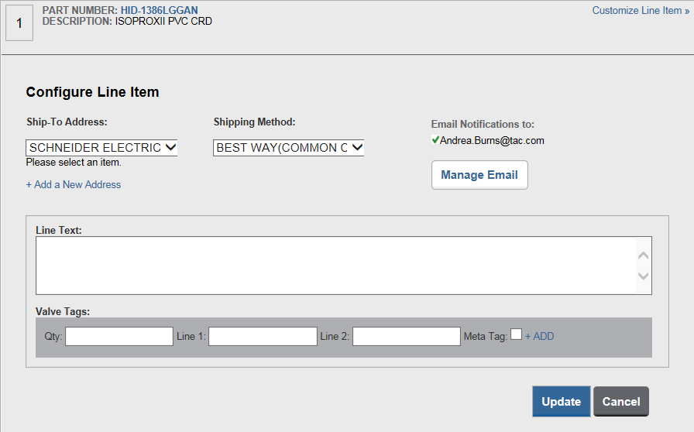

To improve accuracy and delivery, the HID programming information process is being updated. The customer will fill in the required information in the provided document, then copy and paste that information in the special instructions section found in the CART. With this change, customers will have programming history on the PO for future reference. The programming document has changed to request specific information to reduce confusion of what is truly required.

If this information is not provided, the PO will be rejected by HID.