**Access Expert Academy Training Ordering and Registration Process**



The training program for Access Expert has been updated and built around a dedicated and branded web portal. With the change to a new training portal, we have also updated the ordering and registration to help simplify the process.

This document outlines the new steps to successuflly complete an order and registration.

The process still includes using iPortal but the second step of creating an account on the Feenics site is no longer needed. Once the order is placed, the account will be created and an automated welcome email will be sent to the student to set their login password. This also means that no coupon code is needed because the registration starts with the iPortal order. Once an order is placed, the student should receive the automated email within 1 business day.

The training modules are available in iPortal: [AX Training Modules](https://search.iportal2.schneider-electric.com/search?p=Q&lbc=schneiderelectric&uid=143253036&ts=custom&w=*&isort=displaypriority&method=and&view=grid&af=icat2%3asecurityaccesscontrol_training%20icat1%3asecurityaccesscontrol)

The new academy can be accessed at: <https://academy.accessxpert.com/>

**STEP 1: Purchase your training in iPortal**

* All the training modules are ordered through iPortal.
  + **AX-ATC1V3** – remains the core & required technical certification.
  + **AX-VMT** – new dedicated module for the native Visitor Management feature.
  + **AX-IDST** – new dedicated module for the Bosch intrusion integration.
  + **AX-ADIT** – new dedicated module for the Active Directory integration.
  + **AX-OPT** – new dedicated module for Premise Deployment.
  + **AX-API (AX-V3SDK)** – Advanced training on the API
* The person with iPortal ordering access should login to iPortaland either search by the part numbers listed above or select the following from the menus on the left of the screen: Product Search, Security and Access Control, and then in the training section.
* 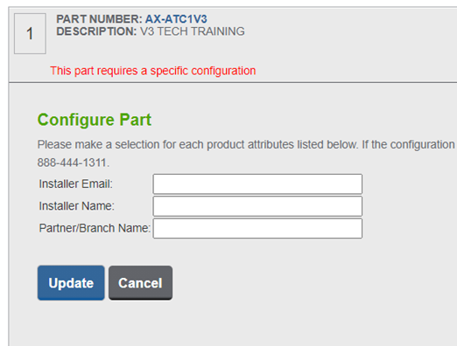Your order should include information about the person taking the training. This information is captured in the pdf training form or by the manual entry fields associated with the item once placed in your shopping cart. The needed information includes the students name, email address and organization name. The fields become visible when you click the Configure Part Option:
* Once the order has been placed, the account will be created and activated within 24 hours. The student will receive an automated email welcoming them to the training academy and will prompt them to login and create a new user password.